Internet Rules

These rules help us to be fair to others and keep everyone safe.

- I will ask permission before using the Internet.

- I will only use my own login and password.

- I will keep my login details secret (although they will be available to my parent(s) and the school as necessary).

- I will only send messages to people I know, or my teacher has approved.

- The messages I send or post will be polite and sensible.

- I understand that I must never give out personal details such as my home address or phone number, or arrange to meet someone over the Internet.

- I will not download or install programs from the internet or from home.

- I will ask for permission before opening an e-mail or an e-mail attachment sent by someone I do not know.

- I will not change any internet or computer settings that may affect the working of the computer.

- If I see anything I am unhappy with or I receive messages I do not like, I will tell an adult immediately. Remember it is not your fault if you get a message like this.

- I understand that the school may check my computer files and the Internet sites I visit.

- I understand that if I deliberately break these rules, I may not be allowed to use the Internet, Learning Platform or computers.

The school may deny or severely restrict access if any of these rules are broken.

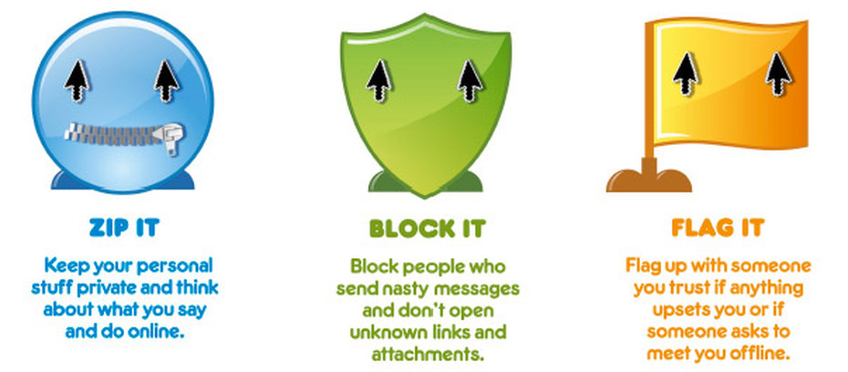

For further information about staying safe on the Internet please visit:

www.thinkuknow.co.uk

